Y0209

Portable Wireless Audio Adapter Mini Bluetooth Receiver / Car Kit Dongle Adapter (Built-in Microphone) for Home Audio Music Streaming Sound System

参考链接：
http://www.amazon.com/Mpow-Streambot-Bluetooth-Receiver-Streaming/dp/B00MJMV0GU/ref=sr_1_1?ie=UTF8&qid=1464230865&sr=8-1&keywords=bluetooth+receiver
http://www.amazon.com/Bluetooth-Receiver-TaoTronics-Microphone-Streaming/dp/B013QJ0W8Q/ref=sr_1_3?ie=UTF8&qid=1464230865&sr=8-3&keywords=bluetooth+receiver

Hand-free calling and listening music in car to ensure driving safety
Up to 10 hours play back
- Wide compatibility with the AUX 3.5 in port it can be compatible with most audio devices , perfect companion for home or vehicle audio systems or headphone
- Support almost all smart phone with bluetooth 4.1, simple and easy to set-up and can connect automatically the next time.
- 2 connection at once , it can connect to two Bluetooth devices at once, enjoy music or listen music , do what you want to do anytime as you like.
- Just one Muti-function button,easy operation, control everything! Answer/End/Reject/Redial/Start Siri assistant/Control music play/Pause
- Support Siri in Apple devices with the long pressing of M button
- Clear talking with built-in microphone makes catching up with friends a breeze

Product Details:
Name:Mini Bluetooth 4.1Receiver
Color:Black
work time up to 14 hours
Bluetooth distance:10m
Bluetooth specification: V4.1+EDR
Bluetooth Operating distance: 30 feet
Running time: about 10H
USB input: 5V/1A

Features

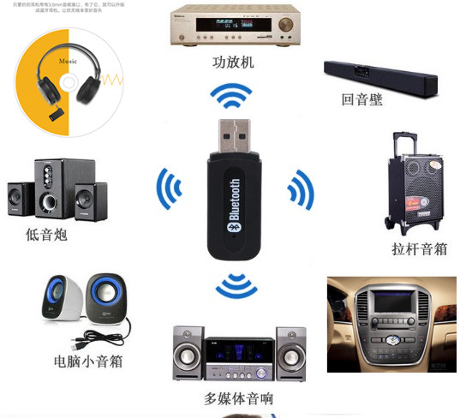

Widely use:
The highly compatible receiver is compatible with a wide range of home stereo systems and car speakers. You can even have it connect to regular headphones to turn them into Bluetooth
instantly
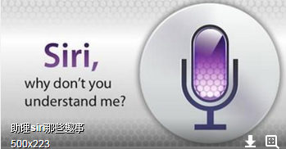
Convenient Siri / Voice Activation, let Siri keep company with you on you driving , never feel lonely and got lost again

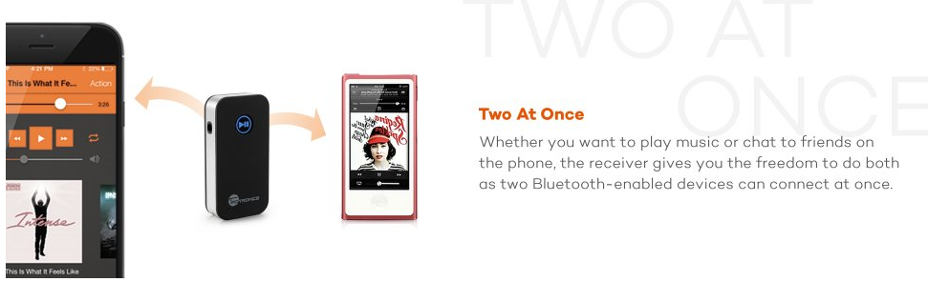
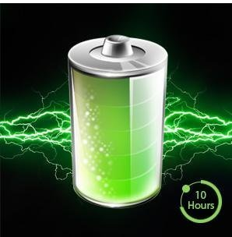
Superior long Battery Life
Still worry about your audio device will run out in the long Journey to make you fell boring ? Just use this item can solve your problem easily , 10 hours no-stop playing music . Long trip can become joyful too!

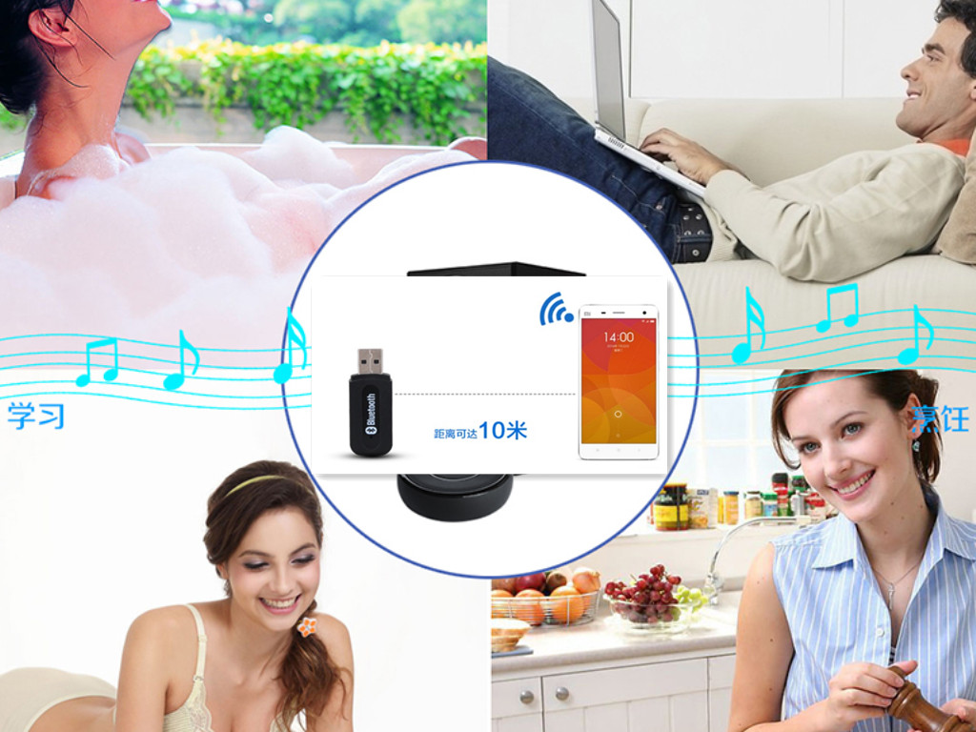
Long distance without disconnection
The distance between the devices is as far as than 30’(10m) when there are
obstacles(e.g.: walls, furniture, etc) between them. Image that you sleep in the couch to control the whole room’s audio system, this is amazing !

Packing list
- Bluetooth receiver 1 pcs
2.3.5mm audio line 1pcs
3.3.5mm audio adapter 1pcs
4.Charge cable 1pcs
5.User manual 1 pcs

